**Data Factory – Integration Runtimes**

The **Integration Runtime (IR)** identifies the compute infrastructure that the Data Factory activity will run on or be dispatched from. If needed it can access resources in public networks and/or private networks. Essentially, it specifies which infrastructure is used to execute activities, where the infrastructure is located, who owns and maintains it, and which resources.

Integration Runtimes can be configured in the Data Factory Authoring tool and are selected when defining Linked Services.

Here’s how to create an integration runtime…

Open connections, then on the integration runtimes tab, click +New:

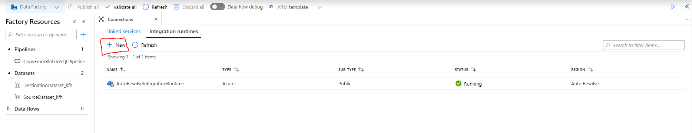

Select Azure, Self-Hosted: Perform Data Movement and Dispatch Activities:

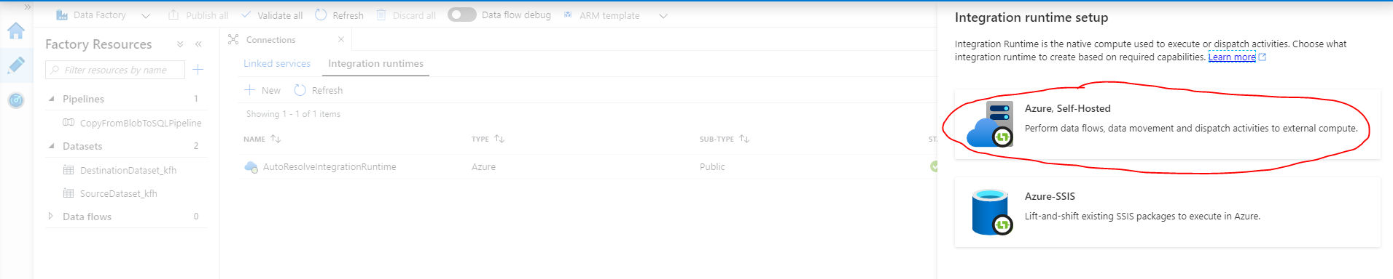

Select Azure integration runtime:

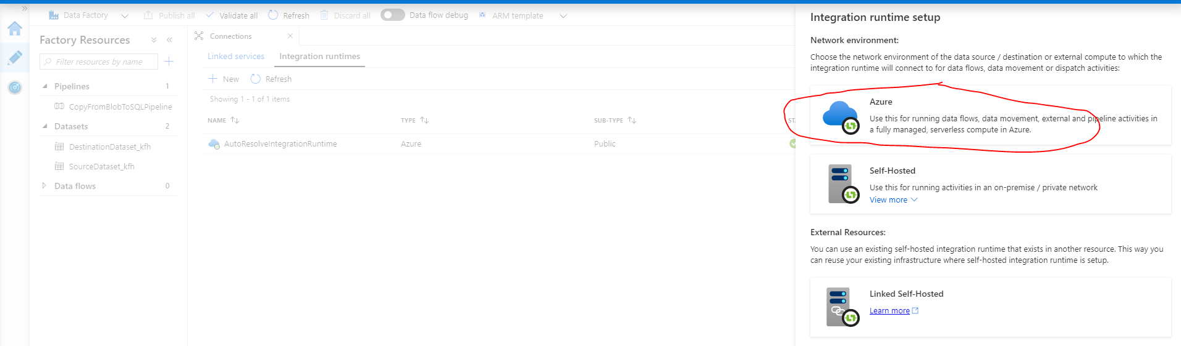

Provide the name, description, and specify the region:

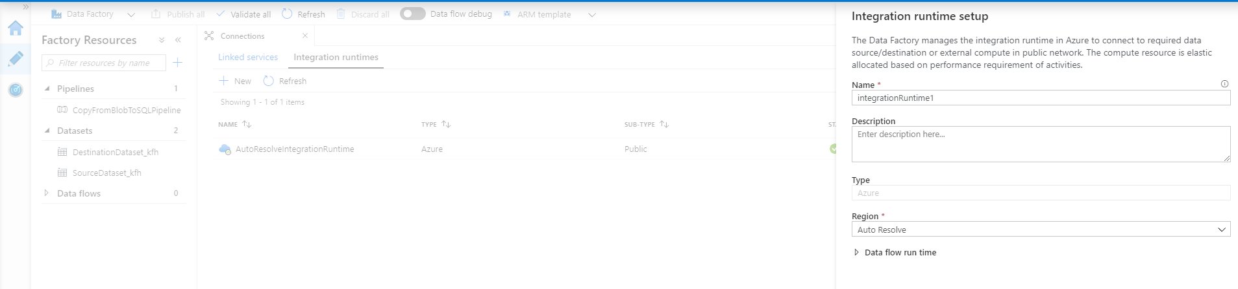

Finally, click create, then you will see your newly created integration runtime:

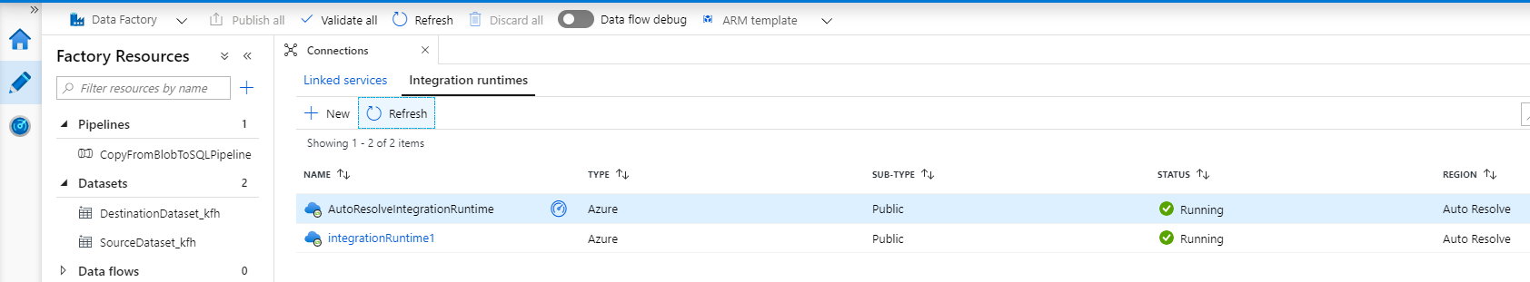

**Other types of Integration Runtimes**

Data Factory offers three types of Integration Runtime (IR), and you should choose the type that best serve the data integration capabilities and network environment needs you're looking for. These three types are:

* Azure
* Self-hosted
* Azure-SSIS

The following table describes the capabilities and network support for each of the integration runtime types:

| **TABLE 1** | | |
| --- | --- | --- |
| **IR type** | **Public network** | **Private network** |
| Azure | Data Flow Data movement Activity dispatch |  |
| Self-hosted | Data movement Activity dispatch | Data movement Activity dispatch |
| Azure-SSIS | SSIS package execution | SSIS package execution |

The following diagram shows how the different integration runtimes can be used in combination to offer rich data integration capabilities and network support:

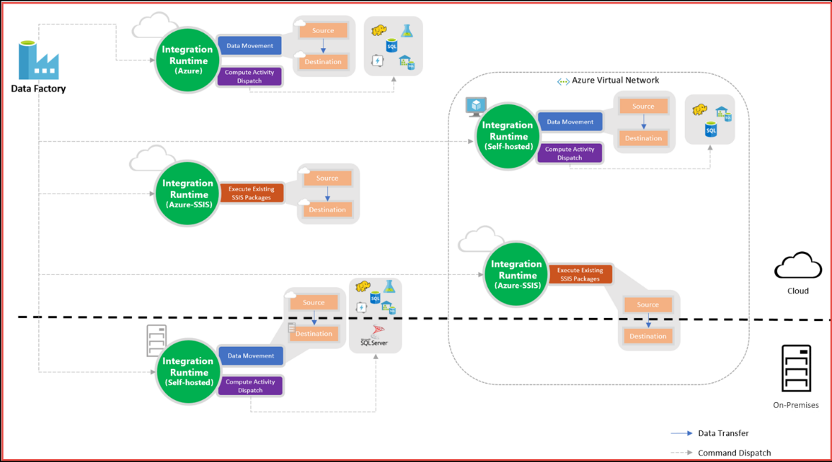

**Self-Hosting Integration Runtimes**

Self-hosted integration runtimes use infrastructure and hardware managed by you. You take care of all the installation, maintenance, patching, and scaling, but you also pay for the time you use it through Azure Data Factory. A self-hosted integration runtime can access resources in both public and private networks.

A self-hosted integration runtime works like a gateway. You install the integration runtime on a machine inside the private network, and then it can communicate with the Azure Data Factory.

**Azure-SSIS Integration Runtimes**

Azure-SSIS integration runtimes are clusters of virtual machines running the SQL Server Integration Services (SSIS) engine, managed by Microsoft. They take care of all the installation, maintenance, patching, and scaling, while you pay for the time you use it. An Azure-SSIS integration runtime is used for executing SSIS packages in Azure Data Factory. Those SSIS packages can access resources in both public and private networks.